Optimizing Graphics Settings:
Note: The images in this document may present differently depending on the specific hardware/software you are working with. If the guide is insufficient refer to the note about utilizing the support request at the bottom of the document.
Note: Following the instructions below is not a guaranteed fix. In some cases, the capacity of the graphics card is not sufficient for the MR3 software requirements.

Finding the Correct Control Pannel:
Depending on which operating system you have (Windows 7,8, or 10) you may be able to right click on any blank space on your desktop to bring up the following options:

If this is possible, click select the NVIDIA Control Panel if available and follow the steps for NVIDIA Graphics Card. If not, select Graphics Properties and follow the steps for Intel Graphics Card.

Alternative options include:
- Click on the windows button (bottom left corner) and navigate to the search bar
- Search for NVIDIA
  - If available Open NVIDIA Control Panel and follow steps for NVIDIA Graphics Card below.
- Search for graphics
  - Open Intel Graphics Control Panel or select Intel Graphics and follow steps for Intel Graphics Card below.

Steps for NVIDIA Graphics Card:
Once in the NVIDIA Control Panel make sure that the settings are the same as those highlighted between the red dots in the pictures below. Do not forget to select apply.
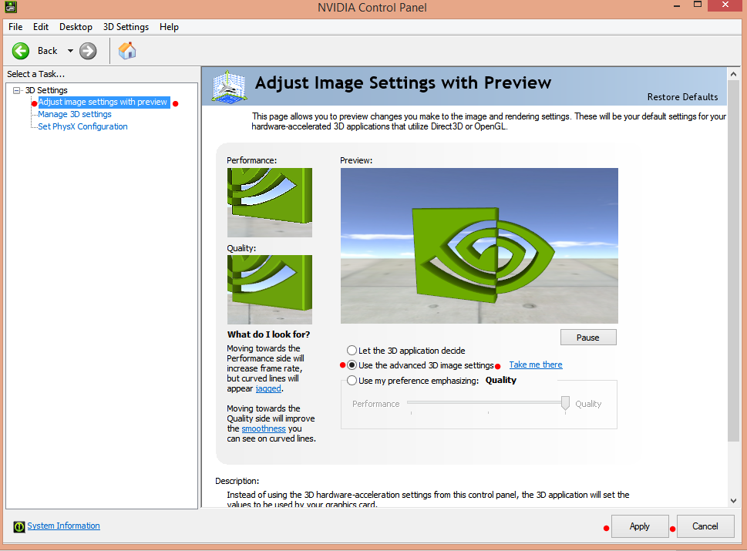
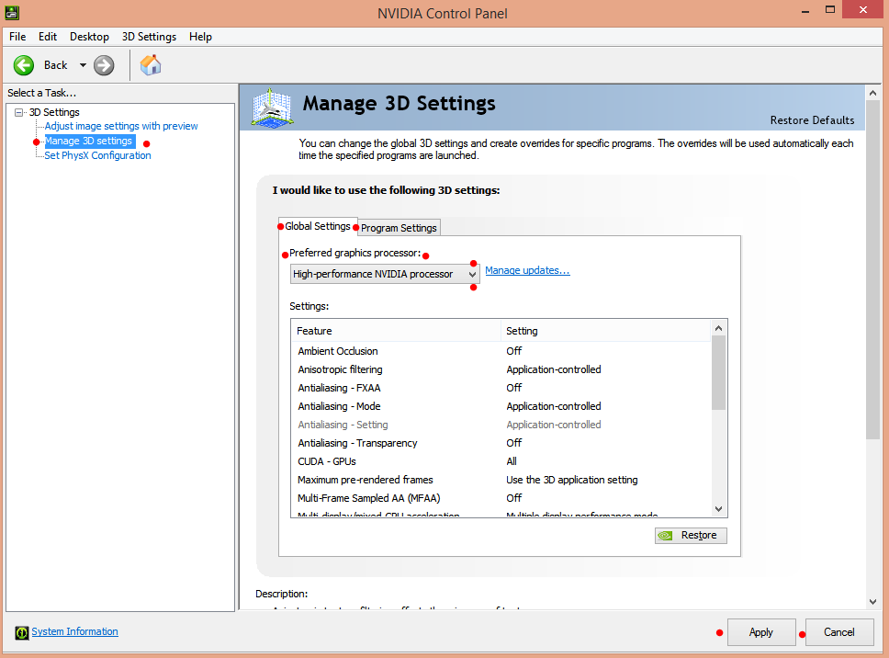

Intel Graphics Card Steps:
Once in the Intel Graphics Card control panel, navigate to the 3D suite and make sure settings are the same as highlighted in the pictures below. Be sure to select apply.

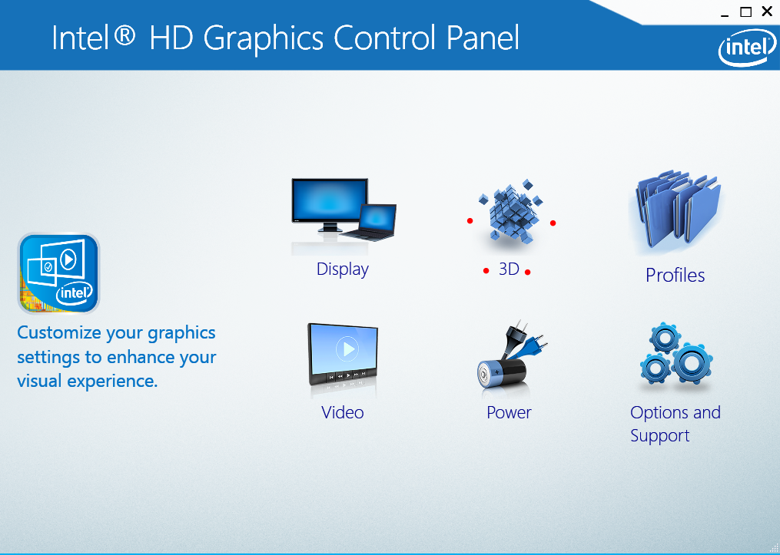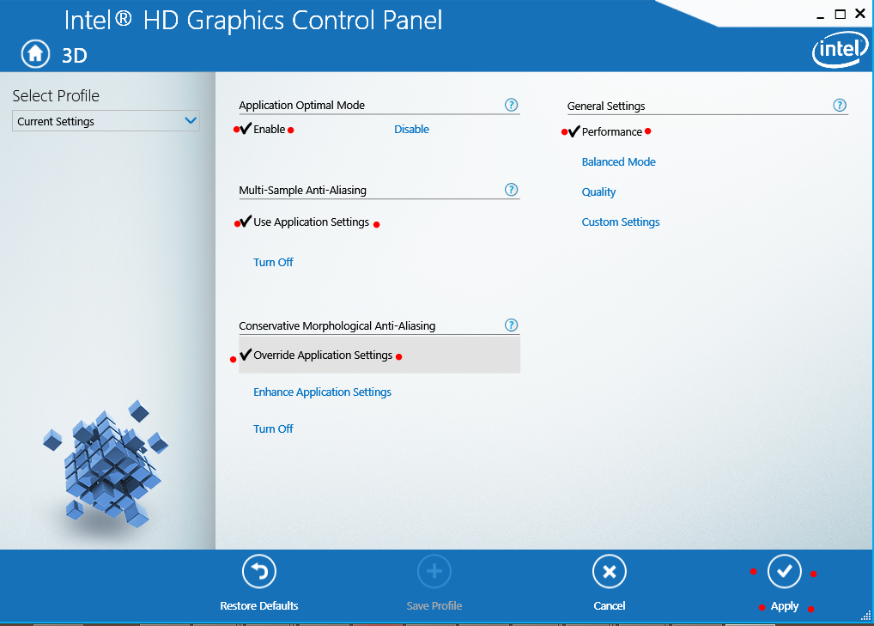

Then navigate to the Power suite and make sure that the settings are the same as those highlighted by the red dots in the images below. Be sure to select apply.
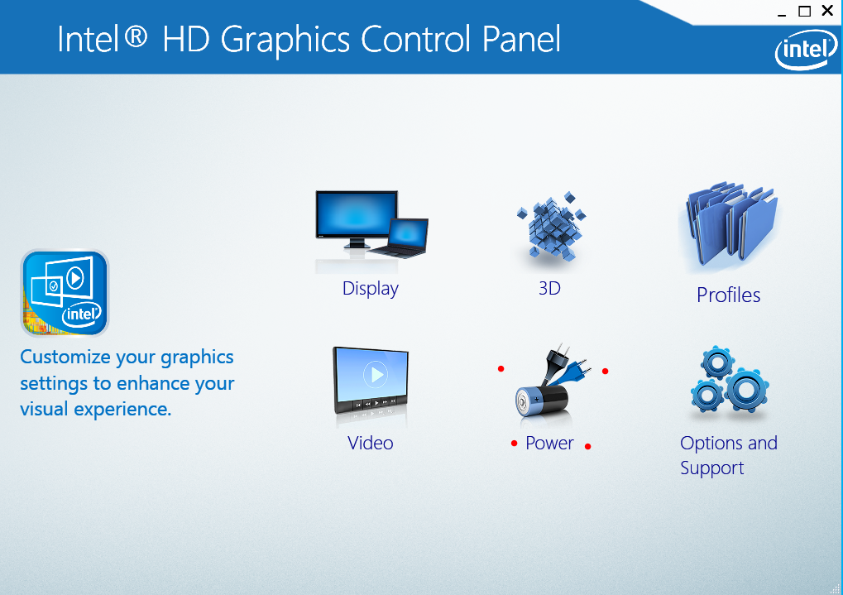
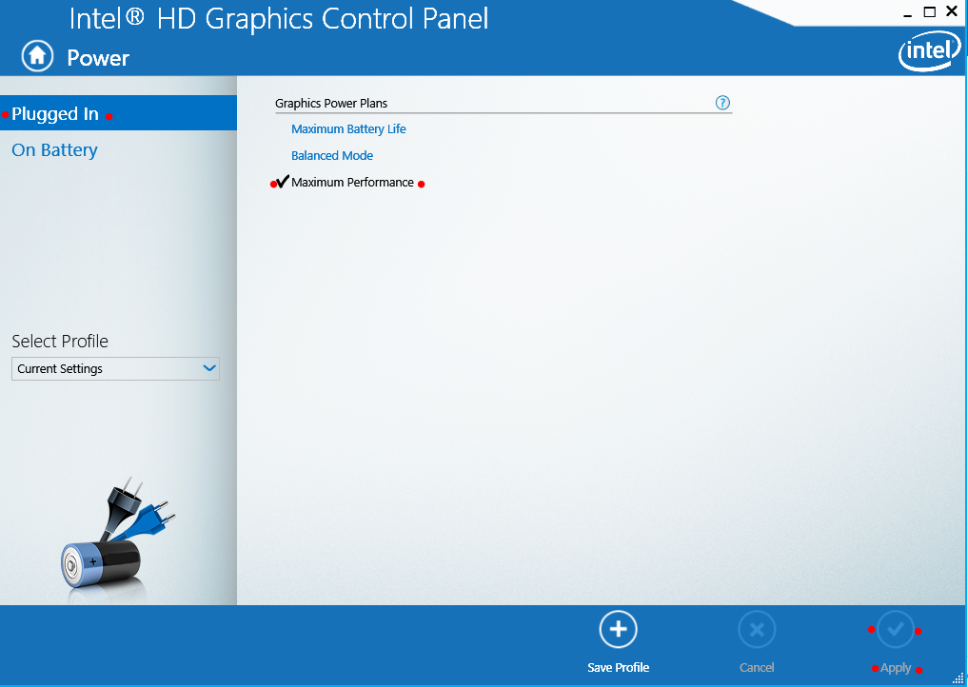
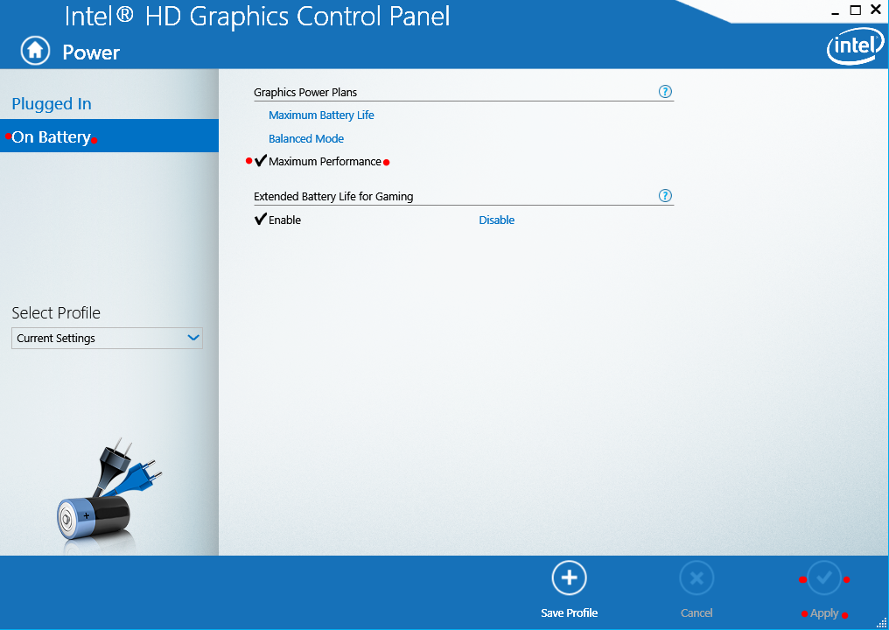

Driver Updates:
- Click on the windows button (bottom left corner) and navigate to the search bar
- Search for and open Device Manager
- Expand Display Adapters
- Double click to open graphics unit of choice
- Navigate to driver tab
- Select update driver
- Select search automatically
- If you do not see the app enter a “downloading driver software” phase, follow the steps below or contact Noraxon support when MR3 software error persists
  - Navigate to driver tab of selected graphics unit previously opened
  - Write down driver version
  - Check the graphics card provider’s website to see if new version is available

Note: You can always fill out a support request form for additional help at the following link.
https://www.noraxon.com/support/technical-support/

Note: For Intel drivers, you can use the link below to update drivers automatically.
https://www.intel.com/content/www/us/en/support/detect.html

